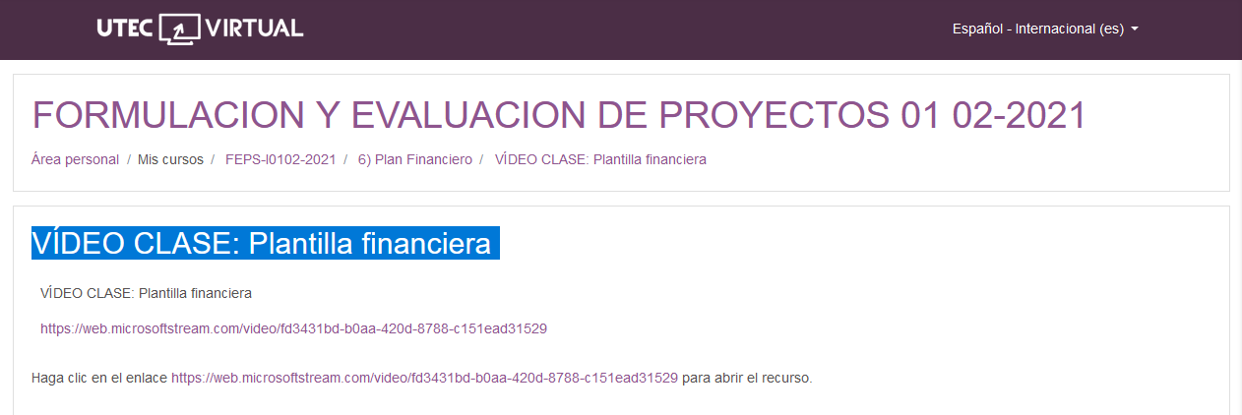

<https://web.microsoftstream.com/video/fd3431bd-b0aa-420d-8788-c151ead31529>